Machrihanish Seabird Observatory (MSBO)
November 2016

Compiled by Eddie Maguire (Warden)

Photo of the Month
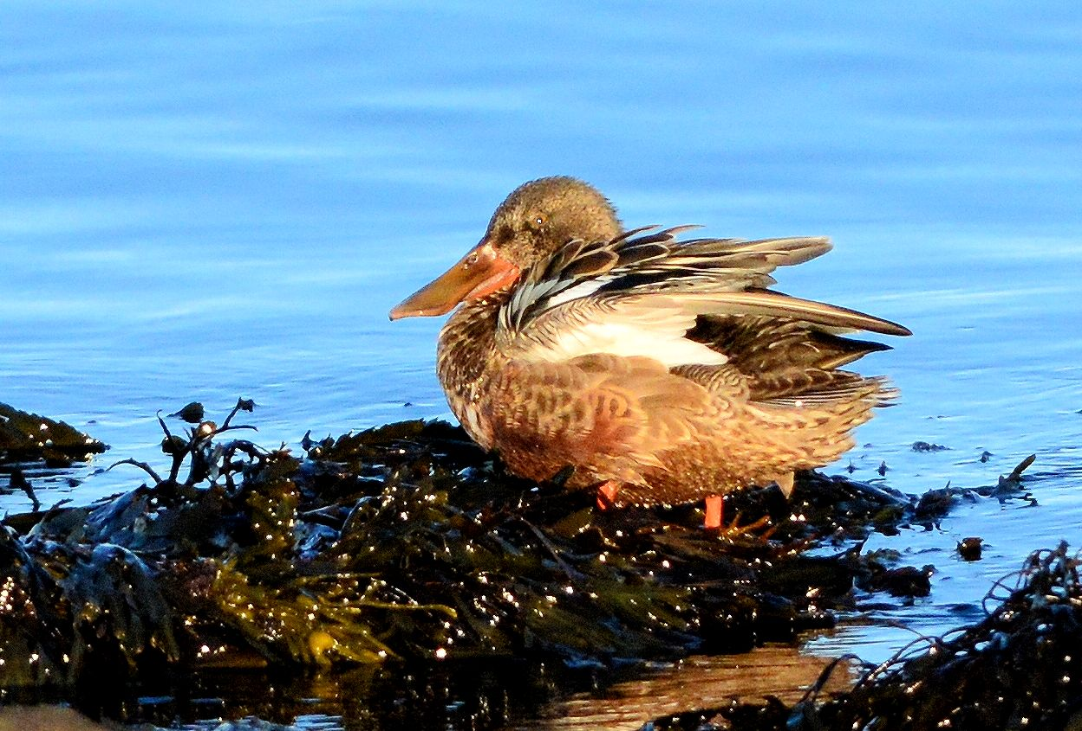
A Shoveler on the shore 24th

2016 at MSBO...
MSBO closed to the public on 31st October after a resolute 245 days (8 months) of manning from 1st March.
This November Report consists of a few casual observations at MSBO and some interesting records from around The Laggan farmlands.

List of Selected Species

Brent Goose
Two on 1st and one on 12th. One passed >S on 16th.

Shelduck
One on 28th and 2 on 31st.

Teal
Four on 6th.

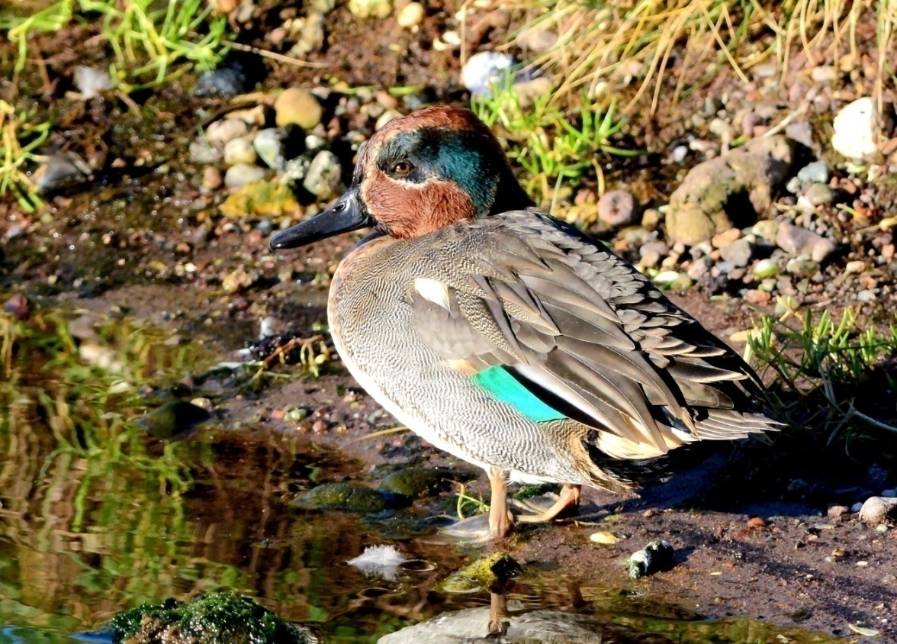
A drake Teal
Wigeon
Seen on all visits with a max of 10 on 10th.
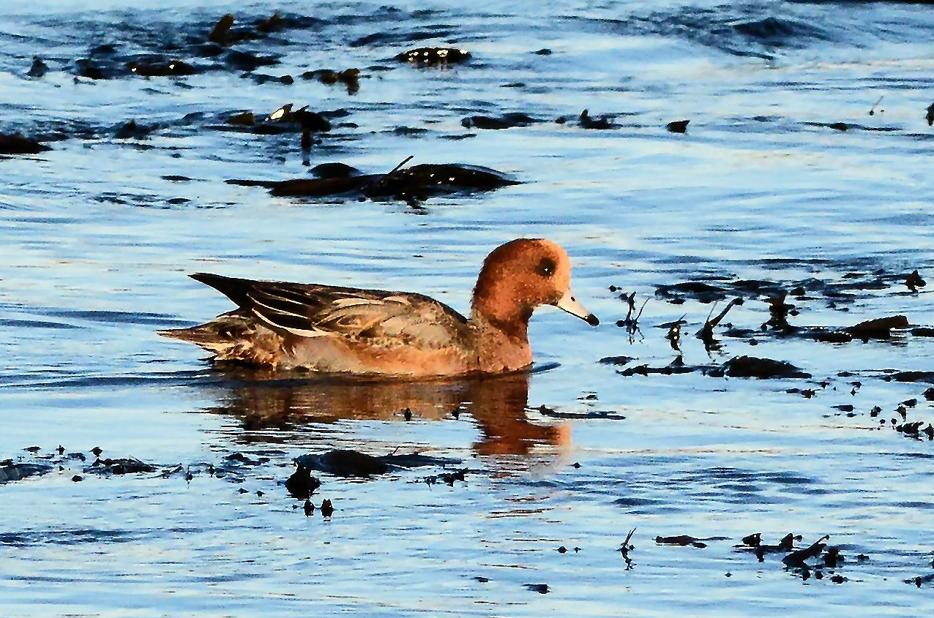
A male Wigeon 24th

Shoveler
One on 24th.
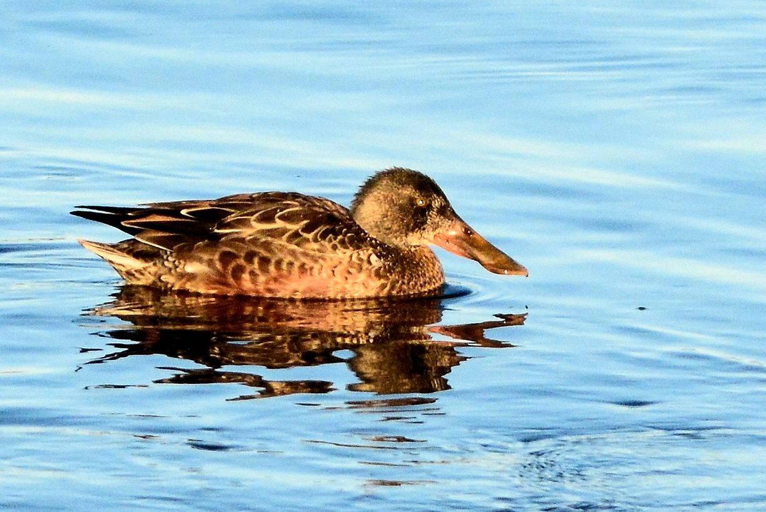
A Shoveler 24th

Common Scoter
Three juveniles >S on 10th.
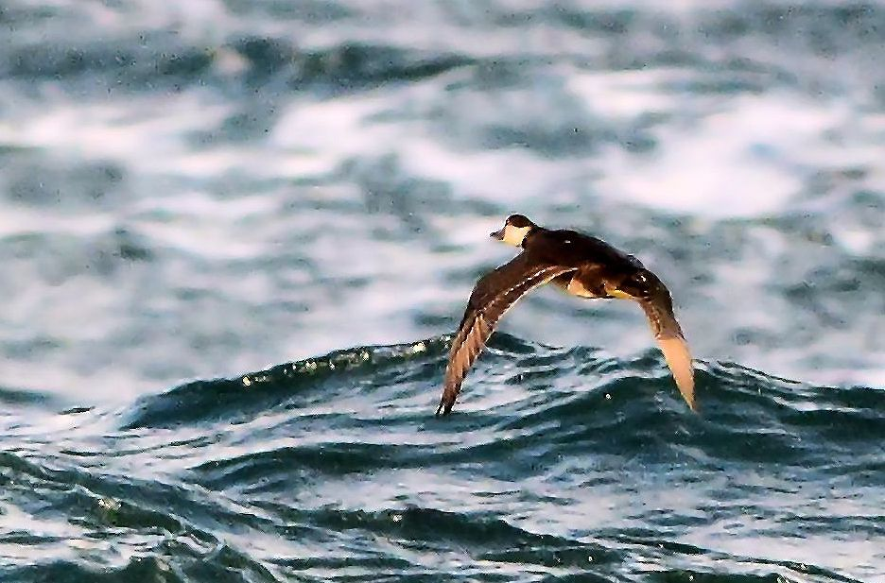
A juvenile Common Scoter 10th

Common Goldeneye
A total of 8 off the old lifeboat station on 31st.
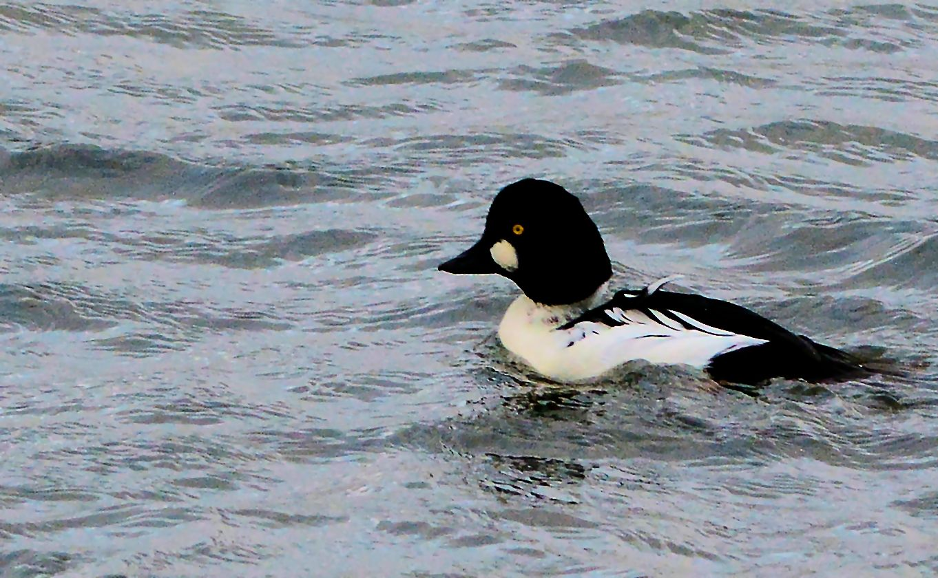
A male Common Goldeneye 31st

Great Northern Diver
Machrihanish Bay: six on 3rd and 9 on 5th.
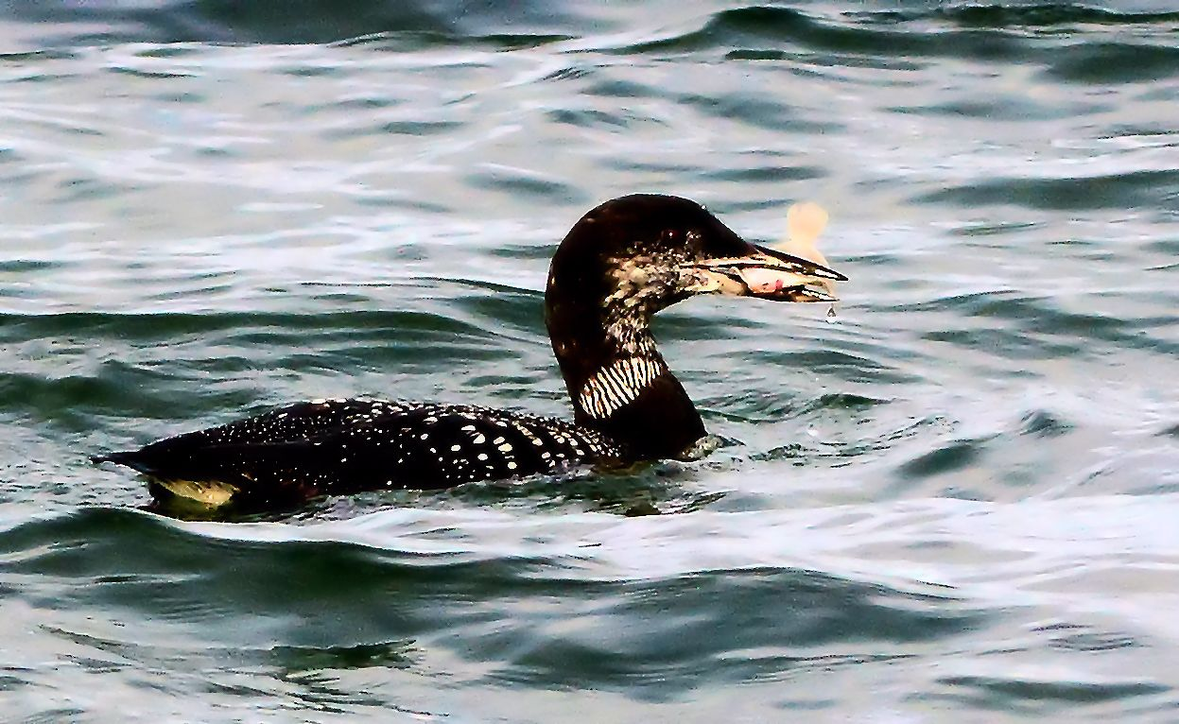
A Great Northern Diver 5th

Ringed Plover
Machrihanish Bay: a flock of 70 on 31st.

Sanderling
Machrihanish Bay: 20 on 2nd - 5th and 30 on 24th.
16 passed >S on 16th.

Purple Sandpiper
A flock of 12 passed >S on 4th and a flock of 8 was present on 16th.
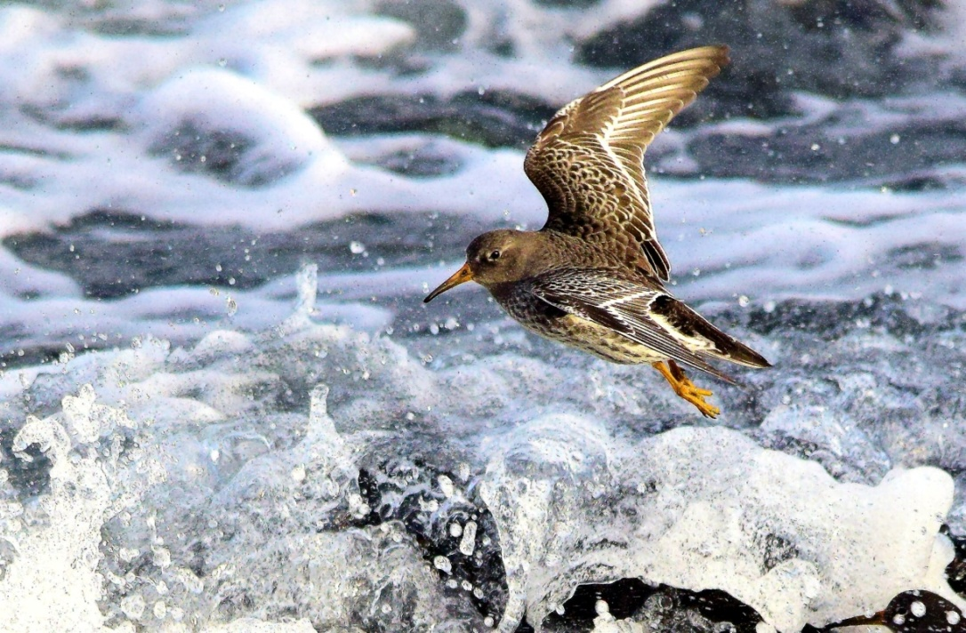
A Purple Sandpiper 16th / Photo Assistant Warden Iomhar McMillan

Common Raven
Two on 31st were both carrying golf balls. Both birds buried the balls in sand.

November Records from around Kintyre

Greater Canada Goose
The Laggan. Bleachfield: 36 on 18th.
Kilmichael (by Campbeltown): 24 on 20th.
Campbeltown: 40 passed >E over the town on 29th.

Whooper Swan
Campbeltown: a flock of 8 adults passed >E on 3rd.
The Laggan: six at Bleachfield (including a juvenile) 10th-12th and 4 adults at The Strath east pool on 14th then 8 adults there on 20th.
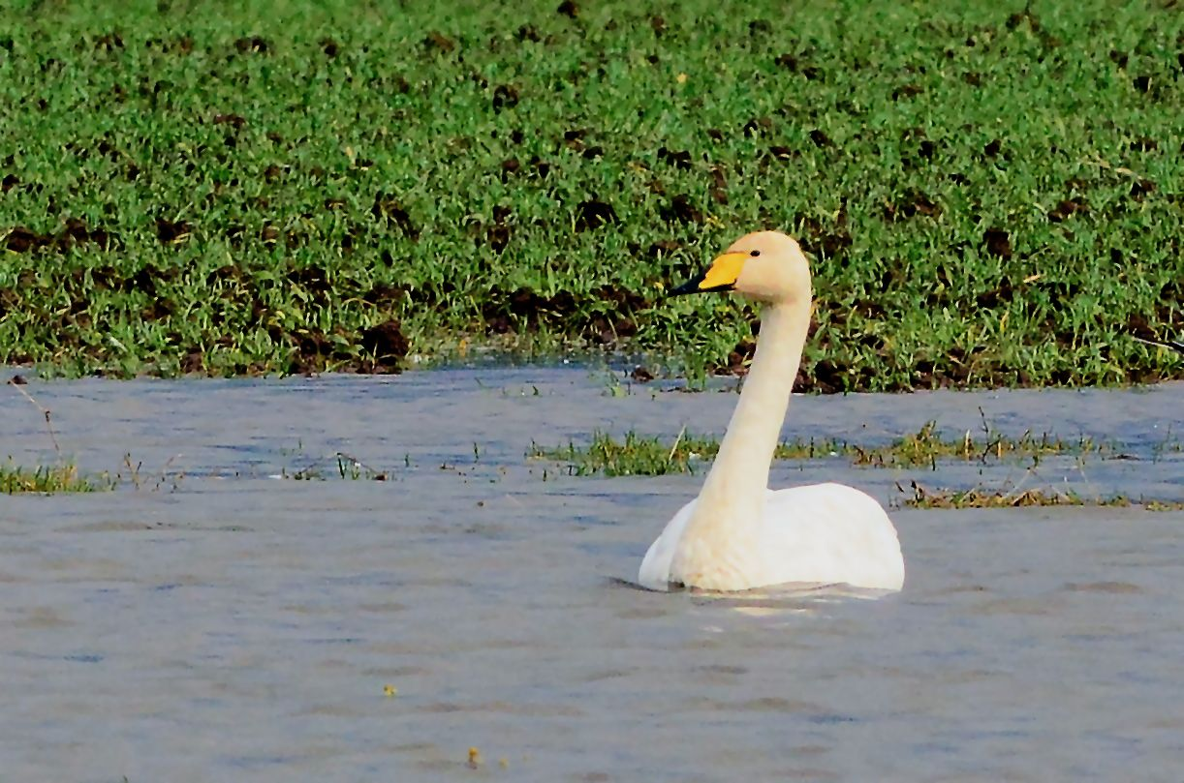
An adult Whooper Swan at Strath east pool 10th

Canada X Barnacle
Strath Farm (The Laggan): 6 hybrids on 23rd.
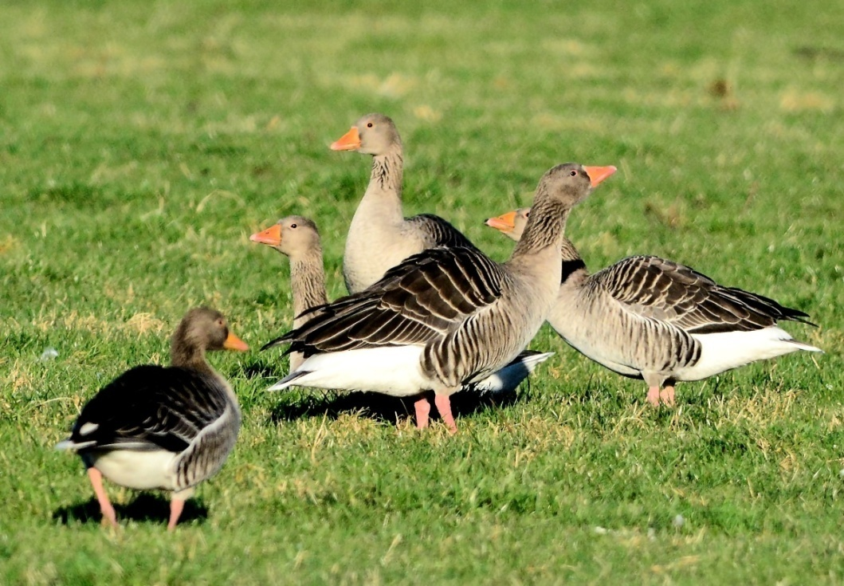
Greylags at Strath 20th
Greylag Goose
At The Laggan.
Bleachfield 211 on 17th.
Strath Farm: 521 on 20th and 644 on 23rd.
Kilmichael (by Campbeltown): 140 on 20th and 80 on 23rd.

White-fronted Goose (Greenland race flavirostris)
The Laggan: ca. 1,000+ over Stewarton on 2nd were apparently the first to arrive in South Kintyre.
Strath Farm (The Laggan):468 on 20th and 530 on 23rd.
Kilmichael (by Campbeltown): 380 on 20th and 290 on 23rd.
This is the second consecutive year that arrivals have been very late. In the past the main arrival date was around 10th October. As last autumn, perhaps the geese are staging longer in Iceland.
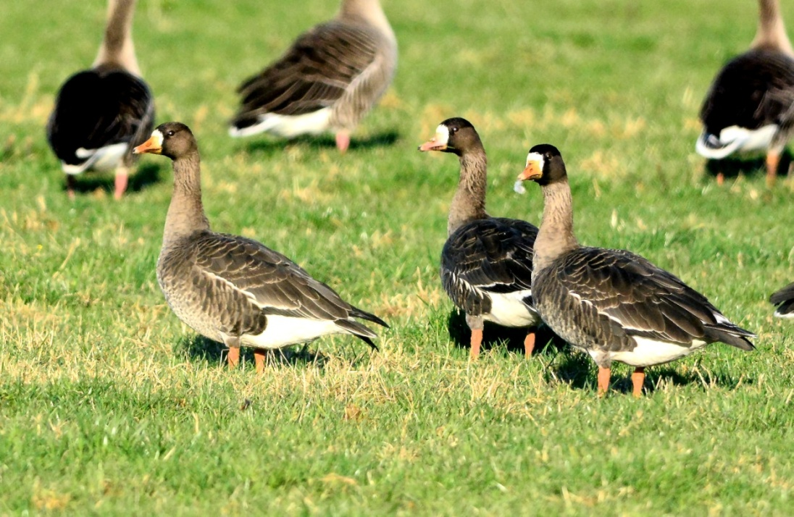
White-fronts at Strath 20th

Shelduck
The Laggan: the first returning bird was at Strath east pool on 17th.

Teal
Kilmichael (by Campbeltown): 52 on 14th.

Shoveler
Kilmichael (by Campbeltown): 2 on 14th.

Wigeon
Kilmichael Farm (by Campbeltown): 400+ on 14th.

Common Eider
Campbeltown Loch inner harbour: a total of 290 on 4th included 176 adult males, 33 immature males and 81 females.

Little Egret
West Loch Tarbert. One on 26th (Toby Green et al / per Jim Dickson).

Lesser Black-backed Gull
Campbeltown. Four first-winter birds were at the harbour on 31st.

Ruddy Turnstone
Campbeltown. The high tide roost at the Ferry Terminal held 42 on 4th and 41 on 15th (Rab Morton).

Black Guillemot
Campbeltown Loch: 18 on 25th.
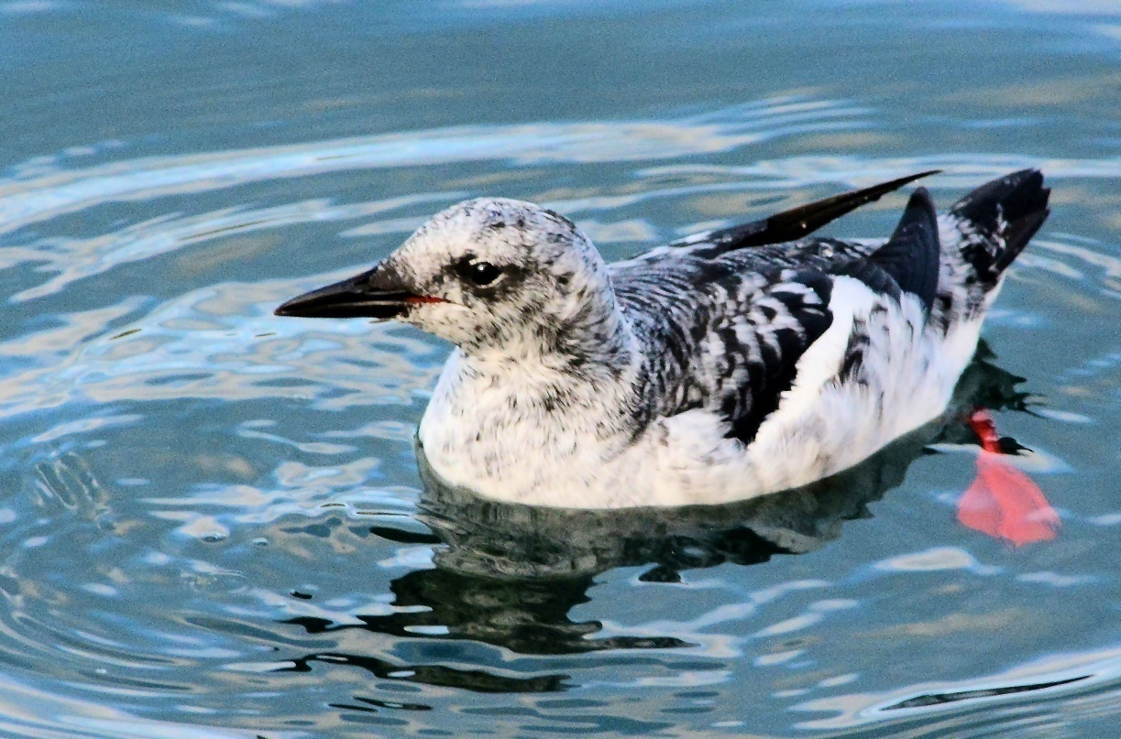
Black Guillemot at Campbeltown 25th

Sky Lark
West Parkfergus, The Laggan: 300+ on 12th.
The largest concentration seen in this area for many years.

Chaffinch
Stewarton: 170 on 14th.

Some more photos from MSBO

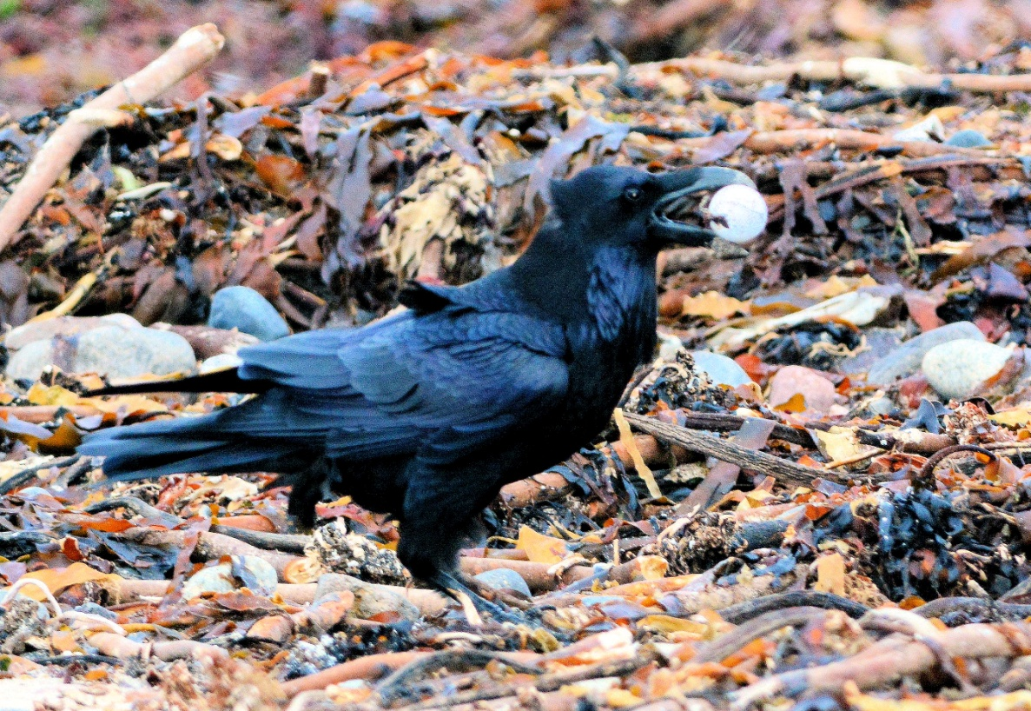
Common Raven 30th with a golf ball

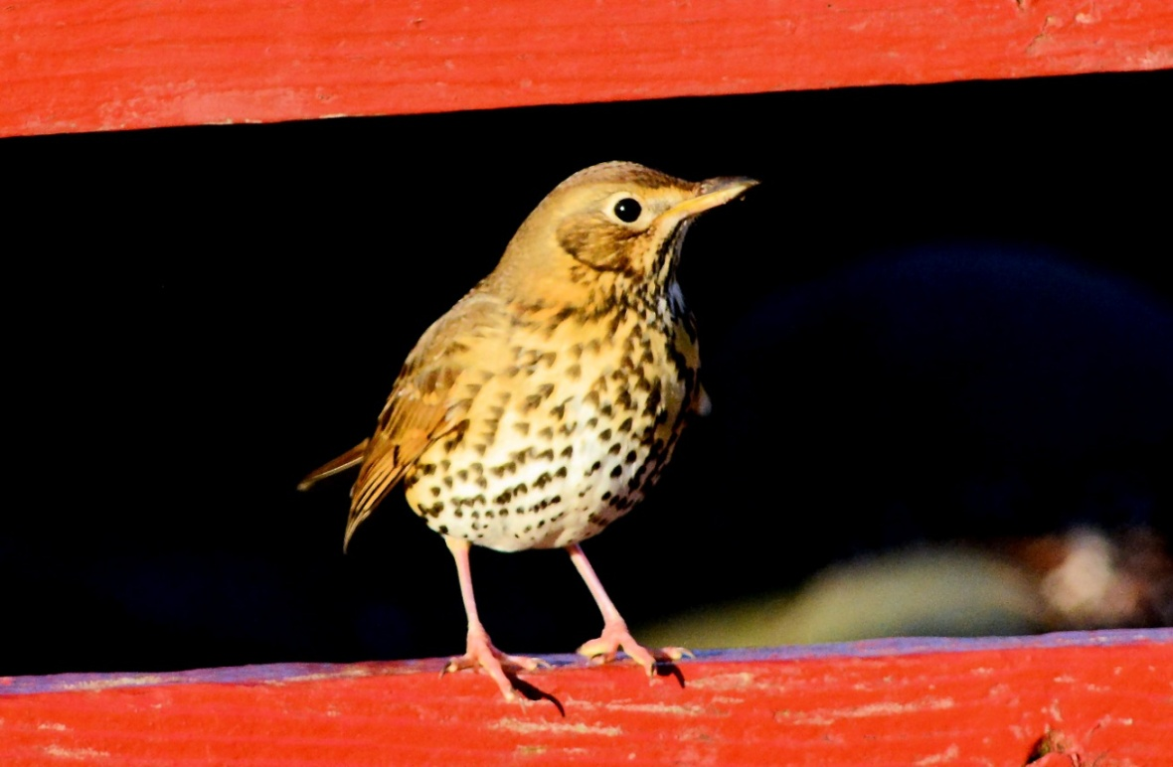
A Song Thrush on MSBO garden gate

